Charlie Nitschelm  
Trevor Blampied  
3/2/20  
China  
Professor Lan

A Comparison with Current Hong Kong Climate to US Situations

# Introduction to Hong Kong Politics

Currently, Hong Kong has a huge political fight going on with the rights Beijing has over the people of Hong Kong. “Hong Kong has Special Administrative Region status which provides constitutional guarantees for implementing the policy of “one country, two systems” (Politics of Hong Kong).” This means that Hong Kong isn’t politically controlled by China, so they have a separation between China’s communist government and the more free-economy and free-speech Hong Kong has adopted since its British rule. “The idea of one country, two systems was proclaimed in which Hong Kong was to govern itself for fifty years, during which it was allowed to issue its own currency, provide its on police and administrative apparatus, continue its separate and independent judiciary, and operate a free and market-based economy (Veeck 373).” Since Hong Kong was transferred to China control in 1997 and the adoption of the ‘one country, two systems’ was agreed upon, Hong Kong has been able to maintain its way of life, and continues to grow stronger as it doesn’t align with the communist way. They still have more than 25 years of this deal being active (Veeck 364). A series of riots have broken out over the past couple of years fighting the invasion of mainland China on Hong Kong’s way of life that have created over the last few decades. These fights wish for a “Complete withdrawal of the extradition bill from the legislative process (Politics of Hong Kong).” One particular issue that has arose from this push is the standard of how Hong Kong chooses its leader, the executive director. Currently, mainland China has put forth a few candidates they approve of that the main delegates of Hong Kong can vote from. This restricts the freedom Hong Kong wants to pick its leader independently from the approval of mainland China. “More demonstrations followed in which local democratic parties demanded a greater voice in selecting candidates for office and a broader suffrage that would enable local people to vote for candidates of their choice (Veeck 375).” Although each political issue that happens around the world is unique, there have been similar events and fights that have occurred within the United States that could be studied to offer more insight to the current climate in Hong Kong now. These include the US Civil War and the current US Gun Rights laws.

# The US Civil War and the Hong Kong Riots

During the era of the US civil war (1860’s), there were two competing goals between the North and the South. The South’s goal was “to secure independence from the North and to establish an independent nation free from Northern political oppression and the repression of slavery (Civil War).”

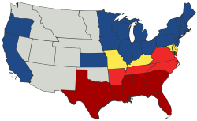

Figure 1 - The breakdown of states in the North and South during the civil war with more neutral states. (American Civil War)

The North varied slightly throughout the fight but essentials “its initial goal was to reconcile the Union, while its mid-war goal became to reunite states under a Union in which slavery was not tolerated. The war from beginning to end would be a noble crusade for democracy for all people, not just in America, but throughout the world (Civil War).” These competing priorities sparked the greatest death war the US has ever engaged in. It is often debated about the overall outlook of the North and how leadership was able to pull such a varied population to fight the South. “To Northerners, in contrast, the motivation was primarily to preserve the Union, not to abolish slavery (American Civil War).” Although it is sad now to think that the people of the North weren’t driven by the idea of abolishing slavery which is so universal within the United States now, the people still stood by the overall mission of the North, which included the removal of the South mindset that so heavily relied on slave labor.

## Similarities and Differences

The end of the 99 year lease of Hong Kong from China to the British can be compared to the Civil War between the North and the South of the United States. Though the origins of the situations differ, the end goal of Hong Kong and the South are similar. One of the goals of the South was to “secure independence from the North and to establish an independent nation free from Northern political oppression…”(gorhistory.com) Along the same vein, one of the Five Demands from the Hong Kong protests is Universal Suffrage for the Legislative Council, essentially allowing them to elect their own government and not be pupated by China.

For a majority of the population in the US during the Civil war, they maintained a neutral state, not wanting to fight their own people. But the drive of a pure democracy against the more slavery-based state of the South drove the people on both sides to fight, as both sides were rooted in what they were taught as they were raised, including the young fighters in the front lines. The same fundamental concept can be seen in Hong Kong, with many of the Hong Kongers taking this invasion of Beijing and mainland China as unacceptable, taking to the streets to vocalize what they believe in, a right mainland Chinese do not have. The situation is different because the area involved in this is so much smaller that the whole community it is impacting is close and well-knit. It drives more people to be aware of what is happening, enabling more communication and organization. China also acts much differently then many other countries in the world in how they deal with their people internally. As we continue to look to the future of how this situation can play out, it is important to note how the US Civil War ended, and how that affected the following years. “The decision to free the slaves on paper via the 13th Amendment did nothing to give them real access to political, economic, or social freedom - thus setting into motion 100 years of Jim Crow laws and racial violence across the nation (Civil War).” Even though a winner will likely arise soon, it is very hard to completely overcome a mindset, either for Hong Kong or China, that has been rooted for so many years in their people.

# US Gun Laws and the Hong Kong Riots

US Gun Laws have been a popular area of discussion and reform over the past several years in the US with the rise of public shootings throughout the country. Fundamentally, many people want more protections for themselves with their families by limiting the guns people can obtain and include deeper checks and wait periods to qualify for a firearm. The pro-gun people, mainly concentrated in the south, have taken to the streets as states begin to create new laws to restrict a fundamental right many believe should never change.

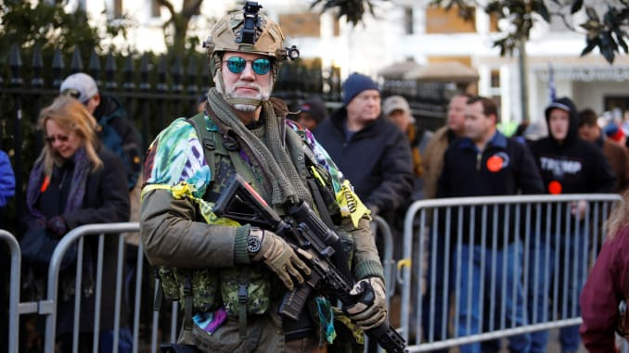

Figure 2- An armed militia overseeing gun right protests (Armed US Gun Rights)

“More than 22,000 armed gun-rights activists peacefully filled the streets around Virginia’s capitol building on Monday to protest gun-control legislation making its way through the newly Democratic-controlled state legislature (Armed US Gun Rights).” The people protesting know that if they fall over in certain areas of the states, it will continue to roll over every state and federal law. “‘What’s going on here, if not stopped, will spread to other states,’ said Teri Horne, who had traveled to Virginia from her home in Texas with her Smith & Wesson rifle and .40-caliber handgun (Armed US Gun Rights).”

## Similarities and Differences

Hong Kongers have organized and protested the invasion of Beijing and mainland China with the same mindset of the states trying to change the law for gun rights. It is a popular mindset that once a fight is not fought for, the frontline for Hong Kong will continue to kneel over for mainland China. In the past, many people have invaded others, but the question remains if what happens is sustainable and actionable. “‘Some of these bills being proposed are just unconstitutional and we will not enforce them,’ Vaughan said. ‘As a sheriff I am the last line of defense between law-abiding gun owners and the politicians who want to take away their rights.’ (Armed US Gun Rights).” Will China be able to ensure that Hong Kongers will respect China and continue to live life adopting the new laws of the land imparted from Beijing.

The situations are still vastly different for the actual outcome of the protesting loss. If US pro-gun activists lose, they suffer the ability to obtain new guns and own their current ones. If Hong Kong protesters lose, they suffer huge amounts of rights many of us take for granted living in the United States. Many Hong Kongers fundamentally do not identify as being a part of China, so the new reality that might await them is frightening. That is the fundamental reason protests have escalated to violent ones in Hong Kong for the overall severity that might hit them if they do not fight and win.

# Moving Forward and Learning

Many of the situations that arise in current politics have been experienced before in other countries or civilizations in our past. It is our job as people to research and learn from what has happened to reflect our decisions now. Although China and the U.S. is vastly different in many ways of life, comparisons can be made that can help navigate people to understand and learn from another. It also helps understand that although we are rooted in differences, both people can experience similar events and situations that occur with any group of people.

# Works Cited

1. Veeck, Gregory. *China's Geography: Globalization and the Dynamics of Political, Economic, and Social Change*. Rowman & Littlefield, 2016.
2. “Politics of Hong Kong.” *Wikipedia*, Wikimedia Foundation, 4 Jan. 2020, en.wikipedia.org/wiki/Politics_of_Hong_Kong.
3. “American Civil War.” *Wikipedia*, Wikimedia Foundation, 30 Mar. 2020, en.wikipedia.org/wiki/American_Civil_War.
4. *Civil War*, gorhistory.com/hist110/unit4/CivilWar.html.
5. “Armed US Gun Rights Activists Rally against Proposed Virginia Gun Laws.” *CNBC*, CNBC, 20 Jan. 2020, www.cnbc.com/2020/01/20/thousands-of-armed-activists-gather-at-virginias-pro-gun-rally.html.